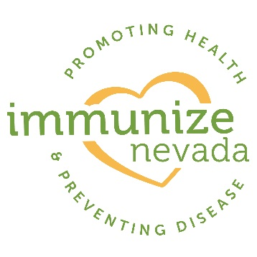

**Press Release Template**

FOR IMMEDIATE RELEASE:

INSERT DATE

List contact: *name, phone and email*

**HEADING:**

Title of Event Happening: *Immunization Clinics Set for Students Heading Back-to-School*

**WHAT, WHO, WHEN, WHERE**:

XXX, NEV. (DATE)— *Summer break is winding down and now is the time for children and teens to receive school-required immunizations. Children heading into daycare, elementary, middle school and college are required, by Nevada State Law, to be compliant and up-to-date with their immunizations. Parents are encouraged to take advantage of free back-to-school immunizations for children 4 through 18 years old, along with health, safety and wellness resources from more than 30 organizations at EVENT NAME.*

**WHAT, AND TIME, EXACT PLACE:**

*EVENT DATE and TIME.**EVENT NAME and LOCATION. All required school immunizations, including Tdap for 7th grade entry, will be available while supplies last for children 4 through 19 years old at no cost. A 20 dollar donation is requested to cover the cost of the vaccine, however no one will be turned away due to inability to pay. Those with insurance should bring their cards.*

**WHY, FURTHER DESCRIBE WHAT; QUOTE:**

*“There have been recent outbreaks of vaccine preventable diseases in California, including measles and whooping cough,” said Immunize Nevada Executive Director Heidi Parker. “Those outbreaks are a reminder of how important it is to make sure our students are fully immunized before heading back to school, as disease can easily spread in the classroom environment.”*

For more information, please visit INSERT WEBSITE or call INSERT PHONE NUMBER.

###

INSERT ORGANIZATION MISSION